[PSoC 4 Pioneer Kit Community Project#021 – Fractional Frequency Synthesizer](http://www.element14.com/community/message/78177" \l "78177/l/psoc-4-pioneer-kit-community-project021-fractional-frequency-synthesizer)

Todays example uses the PSoC 4 device to generate frequencies in the range of 0 - 450kHz with a minimum achievable step size of 0.06Hz. The tolerance on the generated frequency is +/- 1% over a very broad range of frequencies (50Hz to 450kHz). The example then uses the UART bridge to present users a menu in Hyperterminal to select the frequency.

[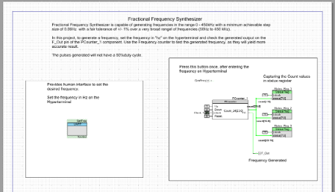](http://www.element14.com/community/servlet/JiveServlet/showImage/2-78177-151272/001+-+Schematic+View.png)

 Forum Post Attachments:

 At the bottom of this post we are including the following items:

* Example Project Zip File
* Zip File of Images
  + Project Schematic
  + Component Configurations

 Components Used:

 The user can download the example project at the bottom of this post. The project uses the following list of Creator Components:

* UART
* Counter
* Status_Register
* Terminal one and zero
* CyClock
* CyPin

 The components are configured by right clicking on the component in your Top Design schematic view and selecting ***Configure***. Please enable the following selections in the Configuration windows for the listed components above.

 Firmware Description:

 The main.c firmware is included in the example project. Please review the commented sections for more details.

 The firmware for this project focuses around presenting a user with a Hyperterminal menu with input and output selections. The user can then enter in their desired frequency to the menu selection and then see that output from the PSoC 4 pins.

 This project interfaces via Hyperterminal using the 9600 baud rate setting. Make sure you have the echo settings enabled on the hyperterminal panel. You will be able to enter in six digits (which should be echoed). Once you have entered in the values then press the SW2 button on the Pioneer kit to enable the frequency.

[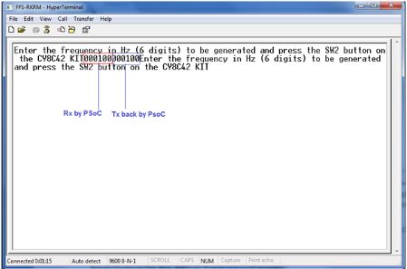](http://www.element14.com/community/servlet/JiveServlet/showImage/2-78177-151271/017+-+Hyperterminal+Output.png)

 Hardware Connections:

 There are no shield connections for this example. Users must connect the UART and frequency generation connections for the example to work correctly. Please see the attached image below.

[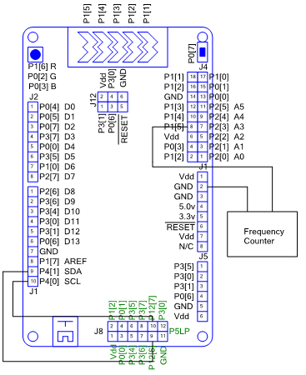](http://www.element14.com/community/servlet/JiveServlet/showImage/2-78177-151260/016+-+Hardware+Connections.png)

 Test Your Project:

 Once the kit is programmed connect to the Pioneer kit and launch Hyperterminal. Enter in your frequency, press the SW2 button, and then see the output. This can be verified by using an Oscilloscope or hardware that can read in frequency. See the image below for the 100Hz example.

[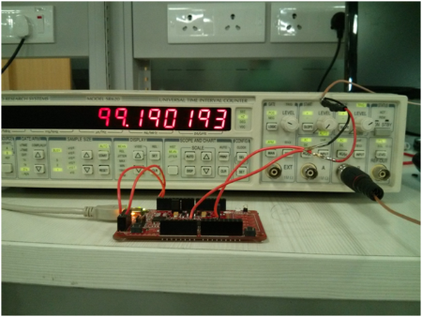](http://www.element14.com/community/servlet/JiveServlet/showImage/2-78177-151261/018+-+Frequency+Testing.png)

I hope this example can help you out in your design.

<http://www.element14.com/community/message/78177>